aAutoHotkey

Setup

1. Locate AutoHotkey installer:
   1. http://ahkscript.org/
2. Run AutoHotkey installer
3. Download script:
   1. Click [File link](https://raw.githubusercontent.com/Pjmcnally/slw/master/autohotkeys/auto_upload_loop.ahk)
   2. Right click in new window
   3. Click “Save As”
   4. Save in “My Documents”
   5. Rename file “AutoHotkey.ahk”
   6. If other scripts are needed files are hosted on my [Github](https://github.com/Pjmcnally/slw/tree/master/autohotkeys).
4. Copy link of AutoHotkey.exe to Startup folder
   1. There is not internal option to make AutoHotkey run at windows start

Issues

The AutoUpload script is still a work in progress. I have done extensive testing and it works very consistently. However, it is possible that it may not work in all possible circumstances. If you come across a situation where it does not behave as expected please let me know.

If a Hotkey goes awry it will continue to attempt to execute its command until it has complete itself. This can be canceled by right clicking on the AutoHotkey log in the taskbar and selecting “Reload this Script”. This cancels the current script and resets AutoHotkey. If you make any changes to a script you must also “Reload this script” before AutoHotkey will acknowledge those changes.

The main issue I have been dealing with is AutoHotkey going too fast and having the commands jumbled or misinterpreted by the browser. This can manifest in several ways but the most typical is that it will not upload the correct number of references instead it simply keeps overwriting one of them. If this is a problem on your system you can modify the delay variable in the script. Near the top of the script is a line that reads:

*submitDelay := 100 ; 100 is default. Increase this number to slow down the submission process if it is breaking. Do not set below 100 or errors may occur.*

Increase the number in red. Note 100 is 1/10th of a second. 1000 is a full second delay.

Bulk Upload instructions

1. Have references ready to file.
   1. The references MUST be in a folder by themselves. The script will try to upload all files in that folder.
   2. I also recommend all references be flattened. However, this step is not necessary.
2. Open Chrome or Internet Explorer (Firefox is not supported).
3. Navigate to USPTO EFS and begin filing.
4. When you are ready to upload the references click “Browse”

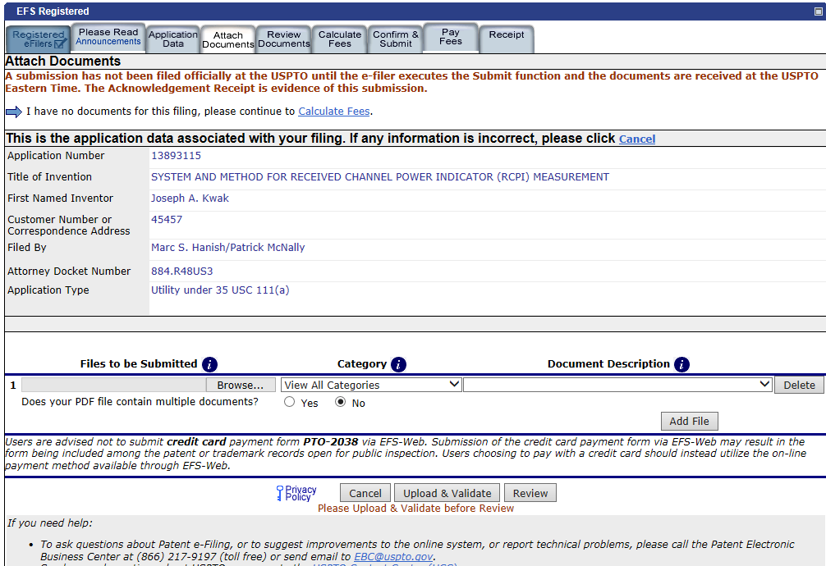

DO NOT CLICK HERE

CLICK HERE

1. In the box that pops up navigate to the folder with the documents
2. Click in the file name box so the cursor is blinking there
3. Press the Hotkey
   1. Press Windows Key + Z
4. Answer the questions
   1. Provide the full file path for the folder that contains the references
   2. Provide the number of the submitted references that are foreign.
5. Don’t touch anything
   1. While AutoHotkey is working if you type or click anywhere you can disrupt it
6. When the first 20 references are completed click uploaded and validate. If there are more the 20 references the script is still running and waiting for the opportunity to provide more references. When you are ready navigate back to the submission page return to step 5.
7. When all references are selected a message will notify you.